ROUND 3 LEADERBOARD

Table | Team Name | Logo | Scenario Name
1 | Learning Illuminators | 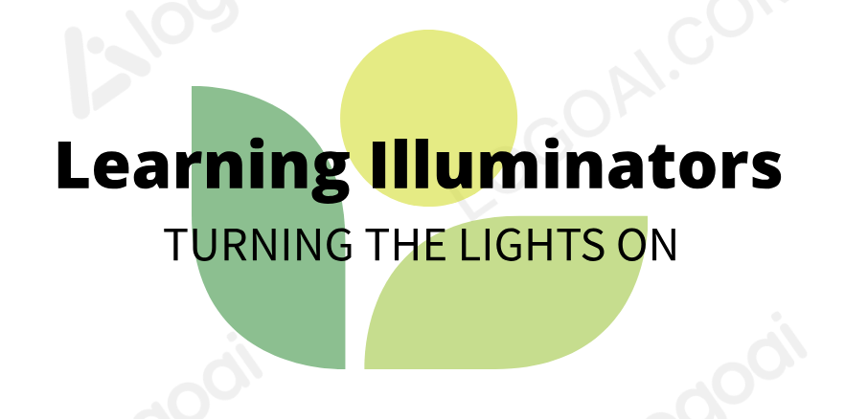 | The Learning Hub: Bridging Tradition and Innovation
2 | Pathway Explorers |  | Pathways of Discovery and Success (PODS)
3 | Bristle Storm |  | AI Companionship
4 | Futures in Education Empowering Tomorrows Teachers (FEET) |  | Innovation from Futures in Education Empowering Tomorrows Teachers
5 | TeachForward |  | InnoZONE

