ROUND 2 LEADERBOARD

Table | Team Name | Logo | Points
1 | Learning Illuminators | 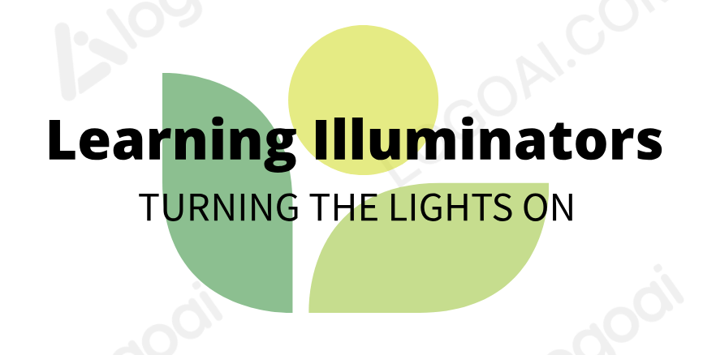 | 2,950
2 | Pathway Explorers |  | 3,357
3 | Bristle Storm | 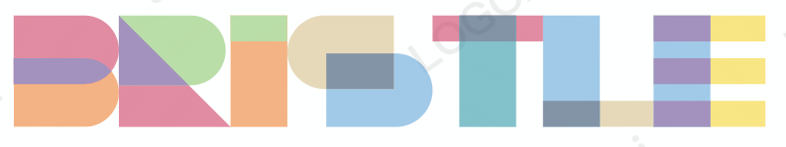 | 250,234
4 | Futures in Education Empowering Tomorrows Teachers (FEET) |  | 7,174
5 | TeachForward |  | 4,562

