ROUND 1 LEADERBOARD

Table | Team Name | Logo | Points
1 | Learning Illuminators | 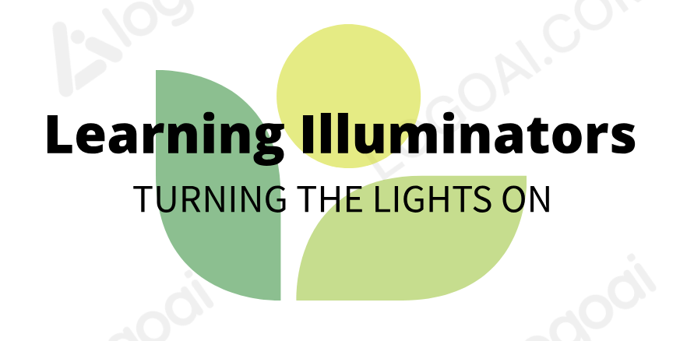 | 202
2 | Pathway Explorers |  | 184
3 | Bristle Storm | 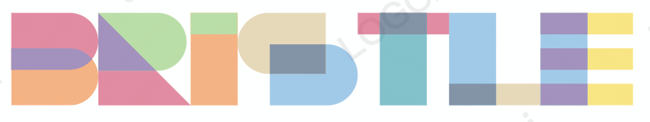 | 131
4 | Futures in Education Empowering Tomorrows Teachers (FEET) |  | 195
5 | TeachForward | 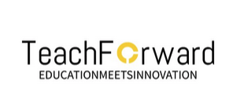 | 220

